

Galley Hill Primary School & Nursery
Special Educational Needs and Disability (SEND)
SCHOOL OFFER

Galley Hill Primary School & Nursery is an inclusive school and may offer the following range of provision to support children with SEND

Intervention
Social Skills programmes / support including strategies to enhance self – esteem

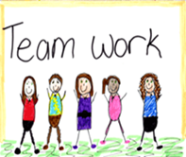

- Wellbeing sessions, Lego Therapy, protective behaviours
- MHST (Mental Health Support Team) counsellor
- PSHE (Personal Social Health Education) lessons

Access to a supportive environment – IT facilities / equipment / resources (inc. preparation)

- Prompt and reminder cards for organisational purposes
- Pre & post teaching of strategies and vocabulary
- Specialist equipment to access the curriculum



Strategies / programmes to support speech & language
ABCDEFGHIJK
elemeno
PQRSTUVWXYZ

- Interventions from a Speech and Language Therapist
- Support from the SLCN team
- WELCOM interventions

Mentoring activities

- Use of talk partners
- Use of peer mentoring
- Support from a specialist TA
- Planned programme from the class teacher



Access to strategies / programmes to support Occupational Therapy / Physiotherapy needs

- Interventions from an Occupational Therapist/ Physiotherapist


Strategies to reduce anxiety / promote emotional wellbeing (including communication with parents)

- Planned programme of support from a classroom teaching assistant
- Meet and greet session at the start of each day
- Withdrawal in a small group for ‘English activities’ including wave 3
- Withdrawal by a specialist teaching assistant for support



Strategies to support / develop English inc. reading

- Small group support in class through Guided Teaching
- Daily reading group
- Pre and post interventions


Strategies to support modify behaviour

Use of school’s behaviour policy: 
- Stickers
- Head Teacher award
- Certificates
Strategies to support/develop Maths

- Small group support from the classroom through Guided Teaching
- Pre & Post intervention teaching


Provision to facilitate/support access to the curriculum

- Small group support from classroom assistant
- Support in the classroom from a teaching assistant to facilitate access through support or modified resources
- Specialist equipment such as seating, soundfield systems, personal screen for visually impaired
- Use of a personalised curriculum

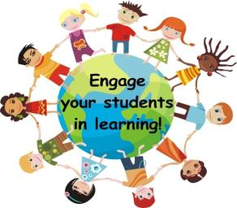
Strategies/support to develop independent learning

- Use of visual timetables and checklists
- Pre teaching of vocabulary and content
- Access to ICT
- Use of individualised success criteria/ top tips



Support/supervision at unstructured times of the day including personal care

- Learning Mentor for playtime/lunchtime
- Named teaching assistant at playtime
- Named midday supervisor at lunchtime
- Specialist teaching assistants available


Planning and assessment

- Individual Educational support Plan
- Individual targets
- Regular review of targets with child and parents
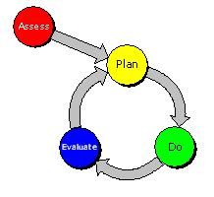
Liaison/Communication with Professionals/Parents/Carers, attendance at meetings and preparation of reports

- Preparation of reports
- Liaison with a wide range of professionals
- Regular progress meetings with parents



Access to Medical Interventions

- Individual support plans for pupils with short term medical needs
- Access to school nursing service
- Strategies for the use of personal medication
- Individual protocols for children with significant medical needs and allergies
- Provision of aids and resources to support learning


Every school in Hertfordshire will offer a range of interventions for children and young people and these will differ from school to school dependent on the school’s organisation.

